

|  |
| --- |
| [Version 1.0]  **Last saved by: Charlotte Hutchinson**  **Last saved on:** 10/12/2014 |

|  |
| --- |
| Iteration 6 Plan |
| [Publish Date] |
| **Charlotte Hutchinson**  CO600: JustHealth Supervisor: Yang He |

JustHealth Iteration 6 Plan

As previously mentioned we have changed for iteration 6 to complete edit and delete medication and prescription for both web and android. Out designs and test cases were already created for iteration 5. The test cases were also created at the beginning of iteration 5 and can be seen in the portal under 6 now.

# Aims:

* To have a fully functioning way for carers to edit and delete medication details for patients.
* To have a fully functioning way to edit and delete appointment details for both patients and carers.

# Requirements:

## 2.1 Functional requirements:

1. The ability for a carer to be able to edit and delete in medication details for a patient- Web
2. The ability for a carer to be able to edit and delete in medication details for a patient- Android
3. The ability for a patient or carer to edit or delete appointment details- Web
4. The ability for a patient or carer to edit or delete appointment details- Android

## 2.2 Non-functional requirements:

1. User Documentation
2. Security
   1. Ensuring only certain people can enter medication details
   2. A safe way for people to enter medication and unable to make human errors
3. Robustness
   1. Error handling
   2. Security (as above)
4. Ease of Use
   1. Simple and intuitive design
   2. Clear colour scheme
   3. Clear and easy way for both patients and users to enter information

## 2.3 Domain Requirements:

1. Security (Android)
   1. Ensuring a user understands the connection with their phone calendar
   2. The app can only link with the google calendar rather than third party ones
2. Push notifications in Android linking with the google cloud
3. Legal
   1. Only correct medication can be entered, ensures validations on fields to prevent human error.
   2. Confirmation screen when medication has been entered

# Design

## 3.1 Android appointment design:

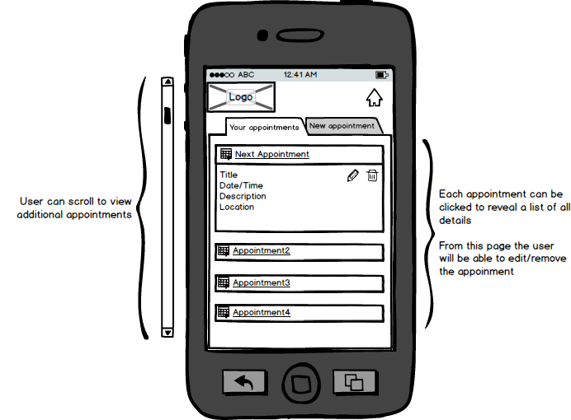

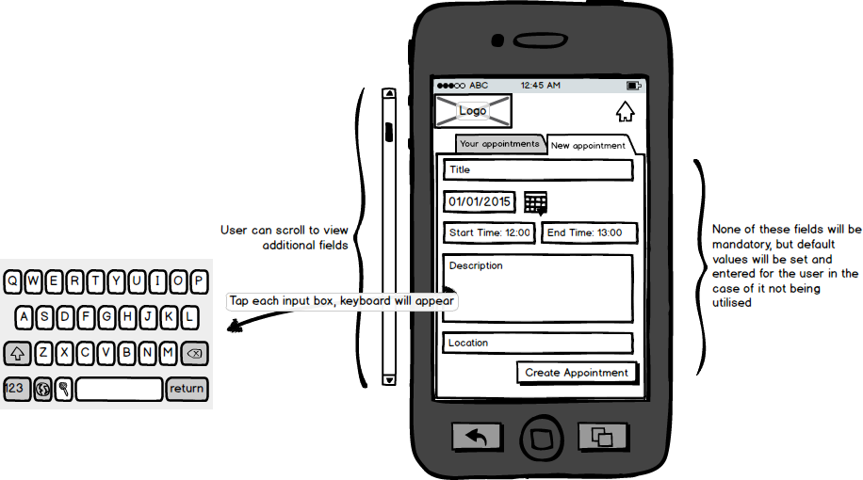

## 3.2 Web appointment design:

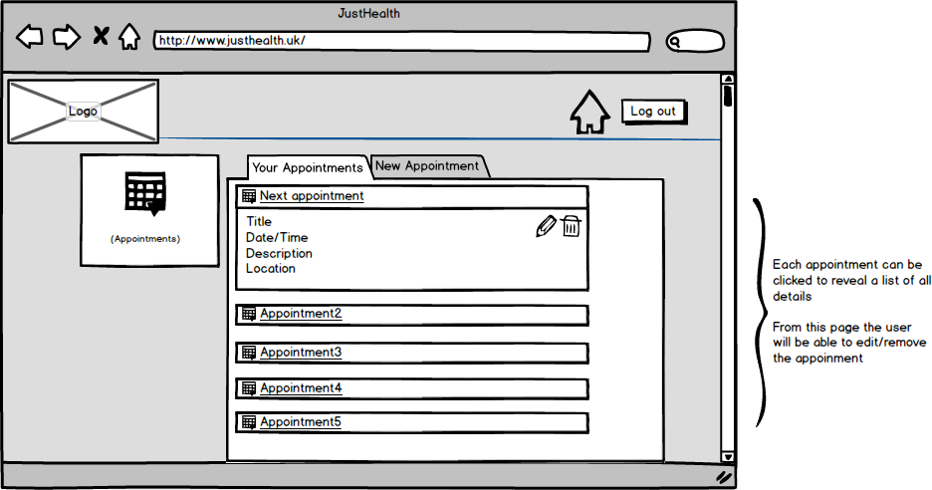

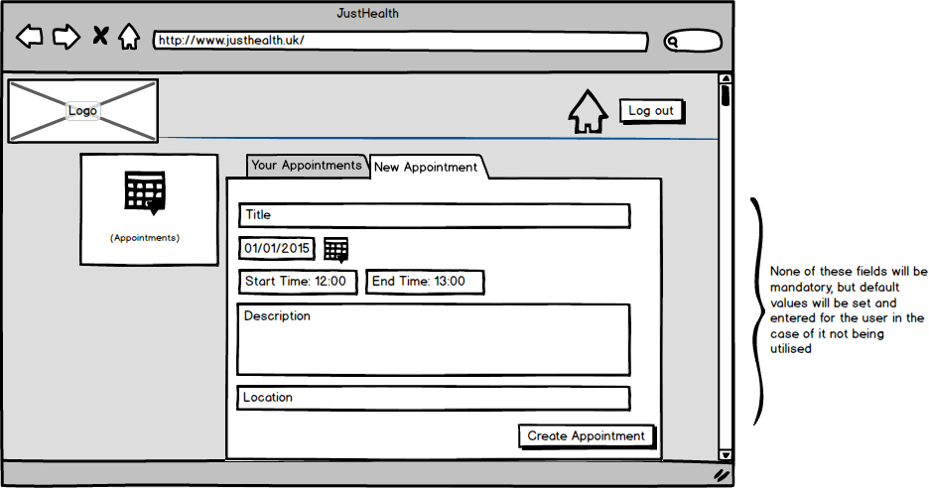

## 3.3 Android medication design

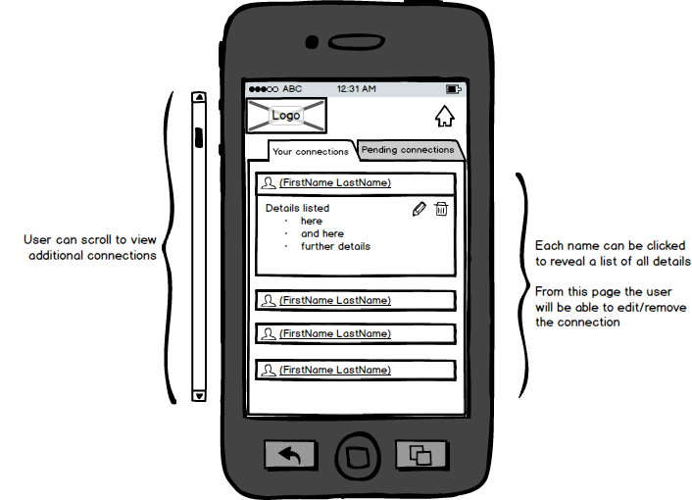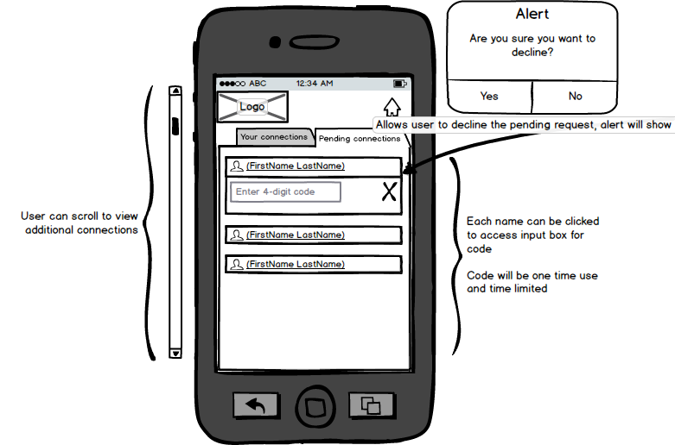

## 3.4 Web medication design

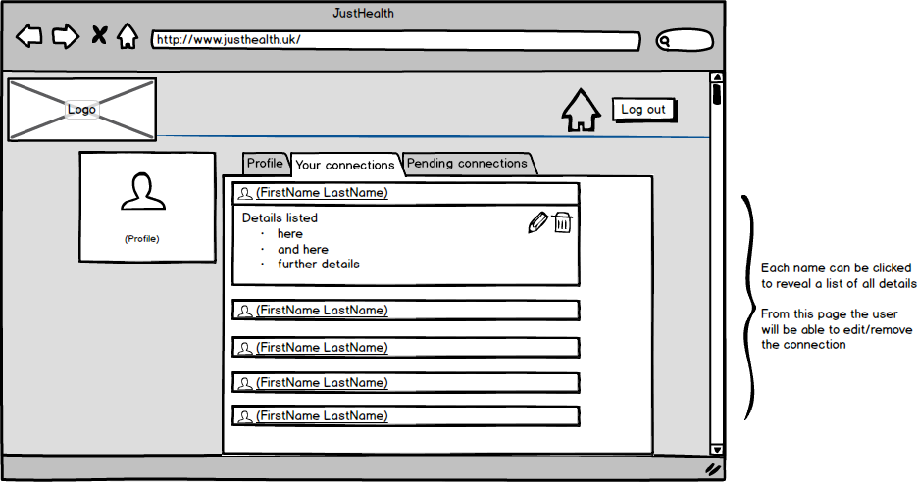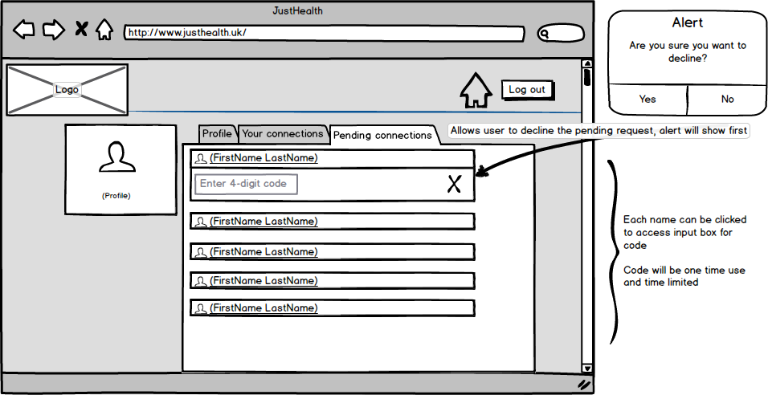

# 4.0 Use cases:

